**Name: Aryaman Mishra**

**Reg. no: 19BCE1027**

**Date: 08-11-2021**

**EXPERIMENT NO: 11**

**Design and analysis of Emergency Lamp**

**Aim:** To design an emergency lamp in LTSpice with the following specifications: Input: 230V 50Hz ac supply Battery: 4.8V (four 1.2 V batteries connected in series) 2 LEDs (in series): NSCW100 with 5 V breakdown voltage.

**Software used:** LTSpice

**Components required:** Resistors, voltage source, NMOS, PMOS, inductor and capacitor.

**Task 1:** Design the input Supply unit with switch control.

**Circuit:**

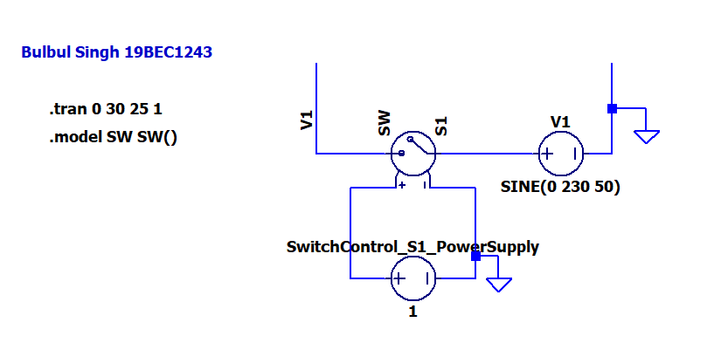

**Output:**

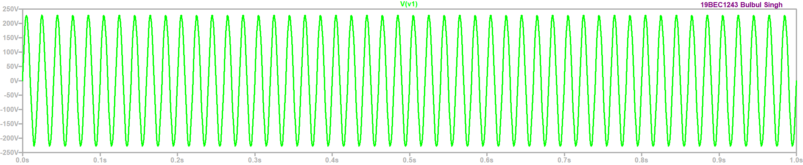

**Result:** Thus we have plotted voltage V1 using switch control S1.

**Task 2:** Design the step down transformer for reduced V2 voltage.

**Circuit:**

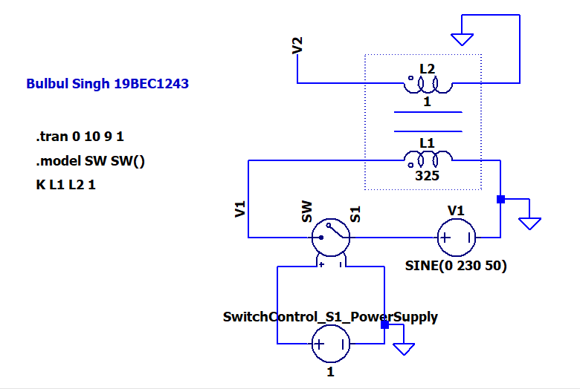

**Output:**

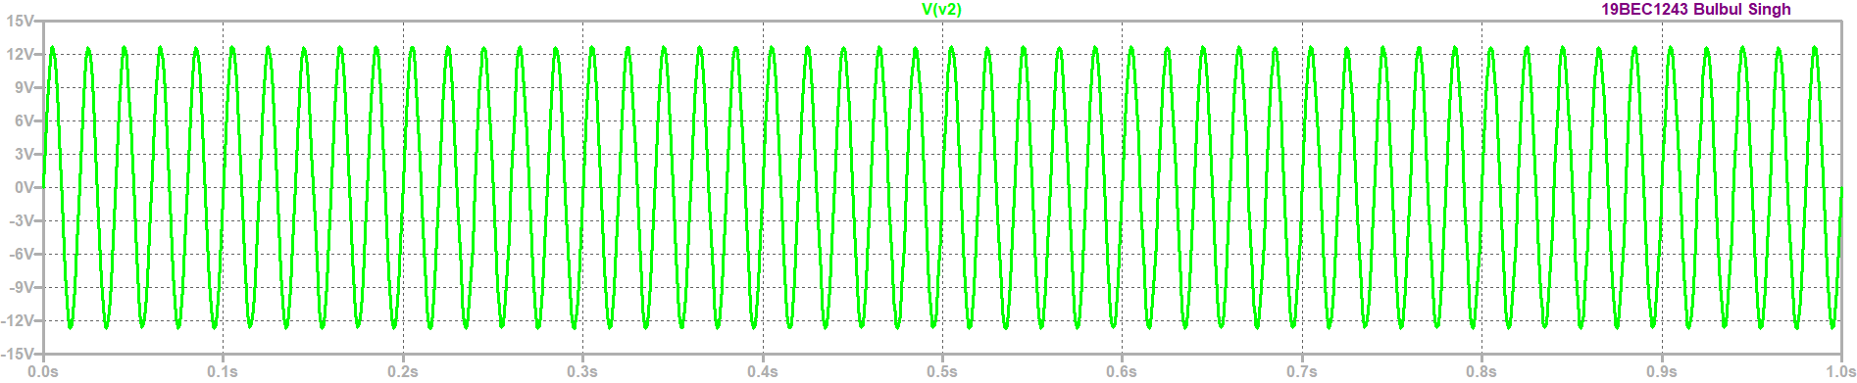

**Result:** From the graph we can observe that the voltage is reduced from 230v to 13v using step down transformer

**Task 3:** Design of Bridge rectifier circuit (without Capacitor).

**Circuit:**

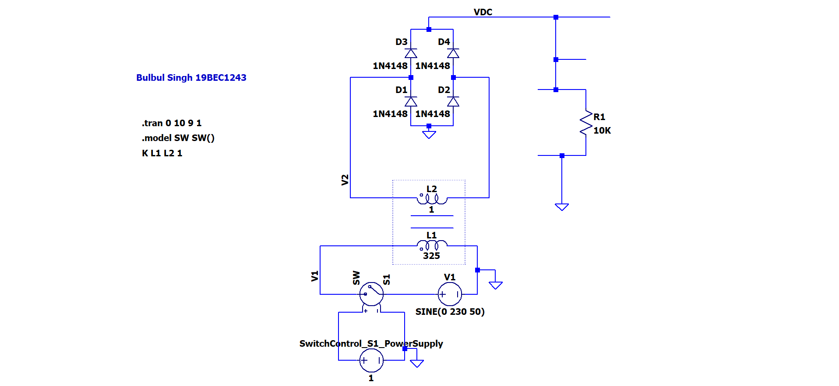

**Output:**

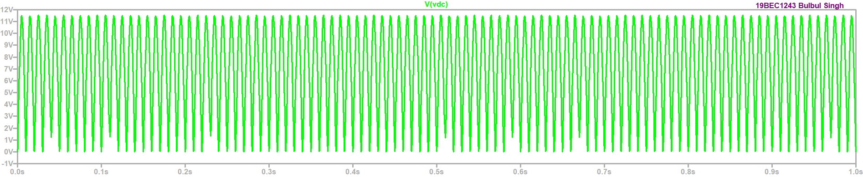

**Result:** Thus we plotted the voltage VDC without using capacitor.

**Task 4:** Design of Bridge rectifier circuit (with Capacitor).

**Circuit:**

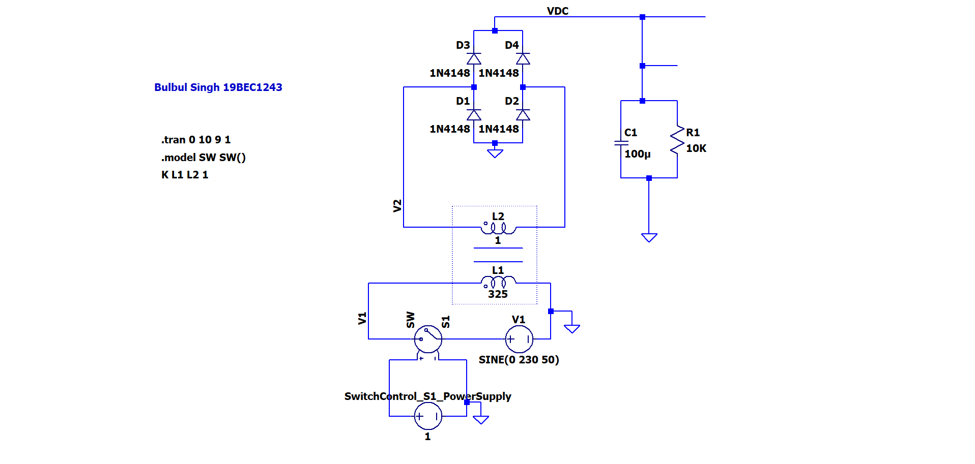

**Output:**

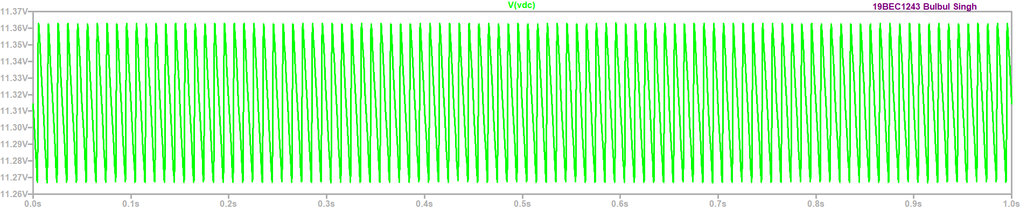

**Result:** Thus we have plotted the voltage VDC using capacitor of 100uf.

**Task 5:** Design of Charging circuit from 12V DC input supply.

**Circuit:**

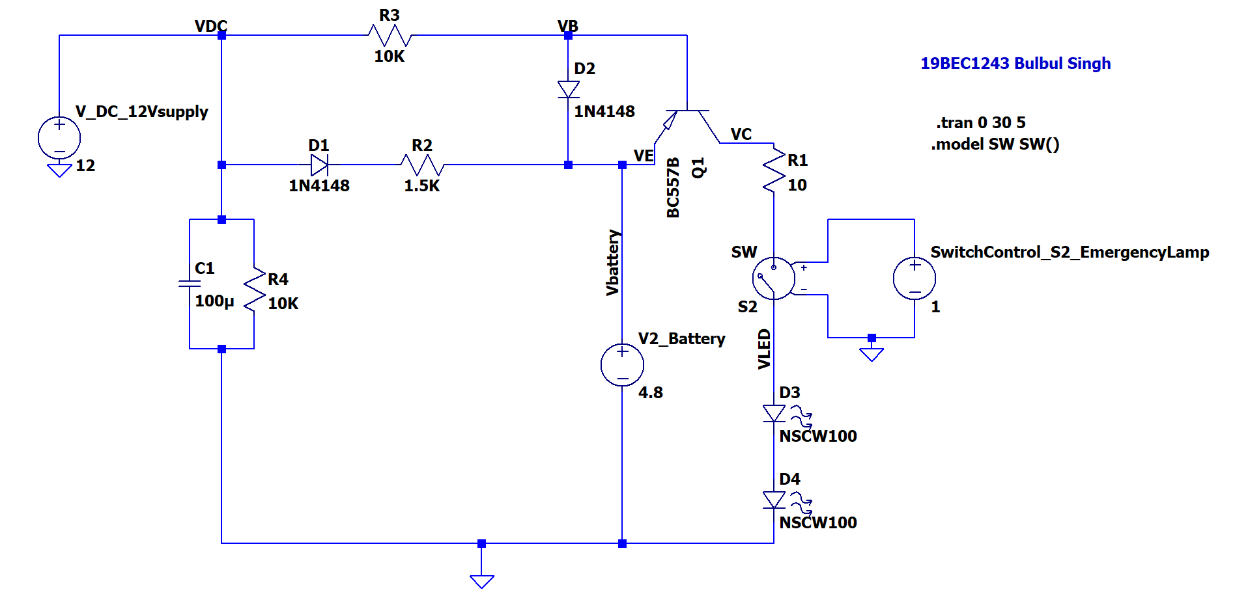

**Output:**

**Case 1: Input DC is on:**

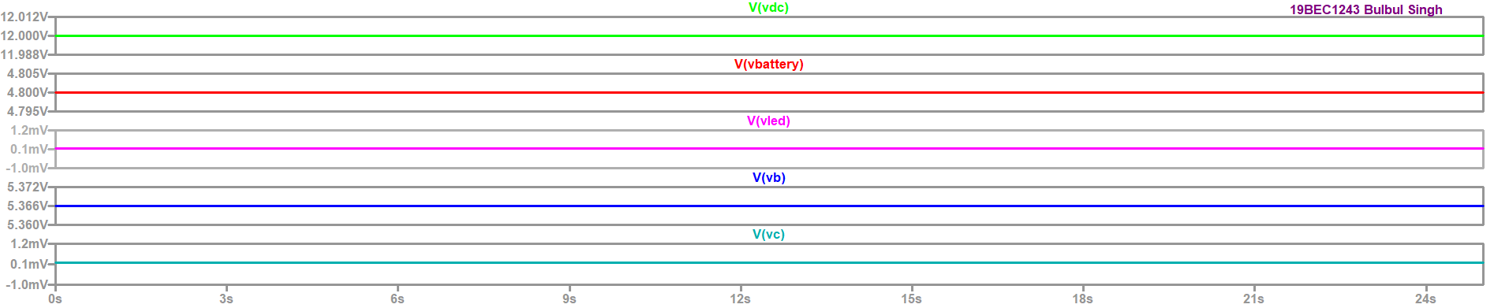

**Case 2: Input DC is off:**

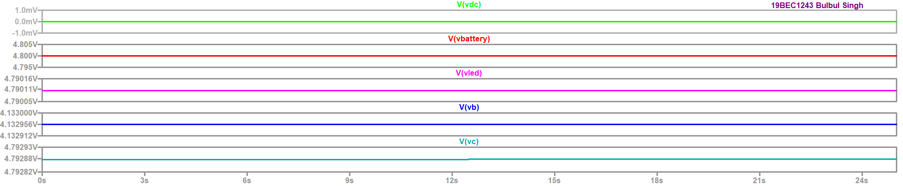

**Result:** From the plots we can observe that when the DC voltage is 12v which is given as a input supply VDC=12v and Ve=Vbattery is 4.8v Vled=Vc=0.1mv so LED is almost in off state.

When the input supply is 0V VDC is 0 so the diodes are reverse biased and Vbattery value is given to Vc results it into turning ON the LED.

**Task 6:** Integrate Bridge circuit to Emergency Lamp: Complete the circuit

**Circuit:**

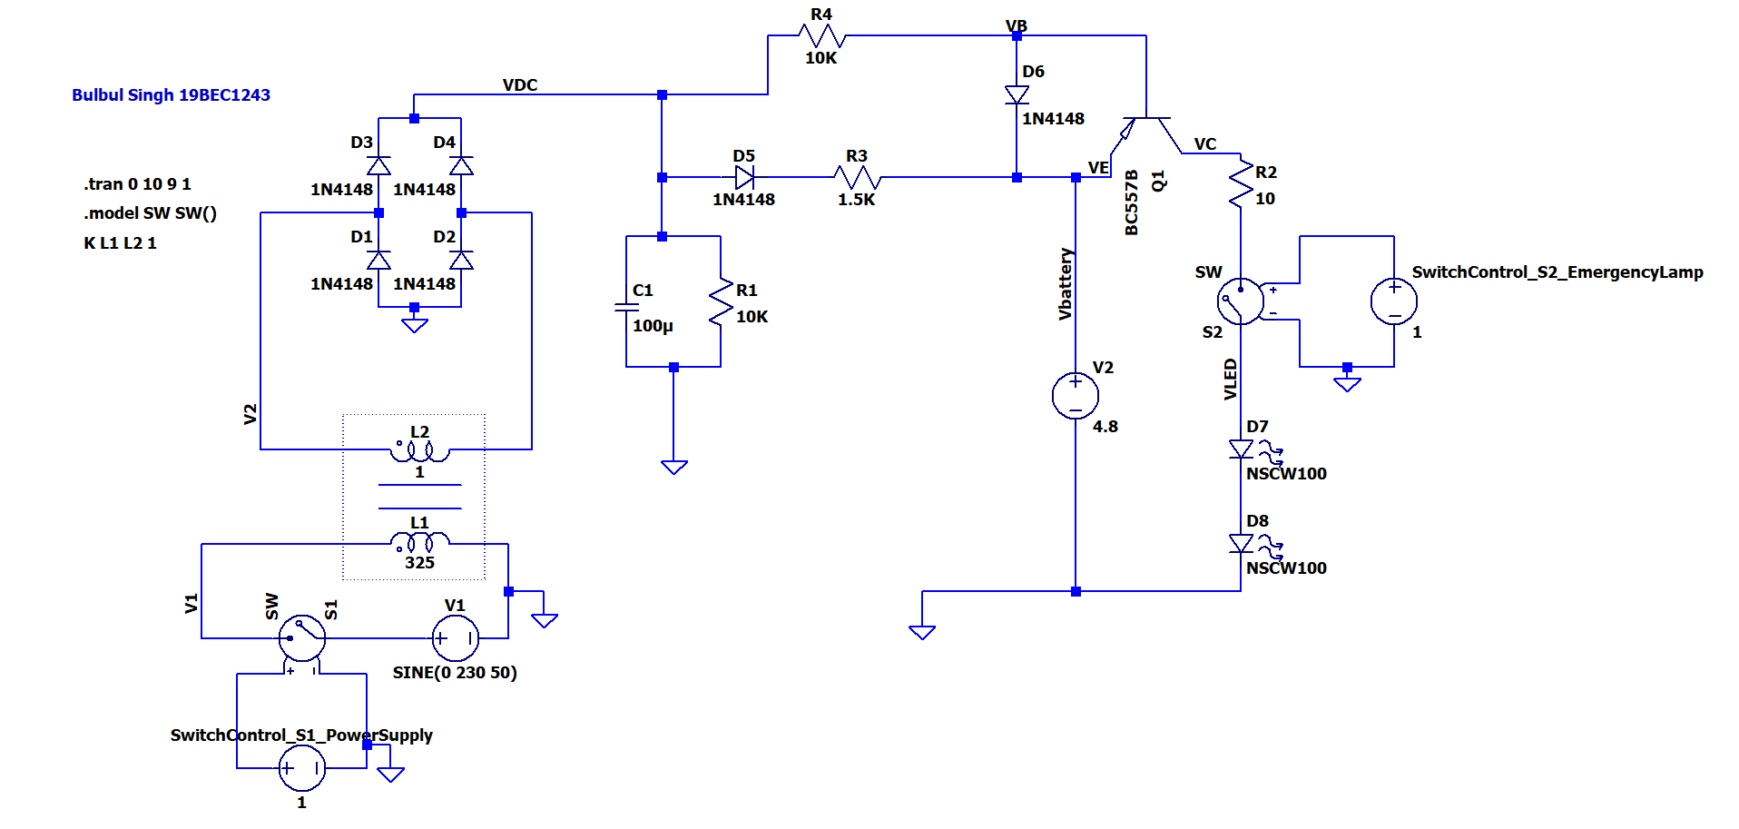

**Output:**

**Case 1: With S1 ON, S2 ON:**

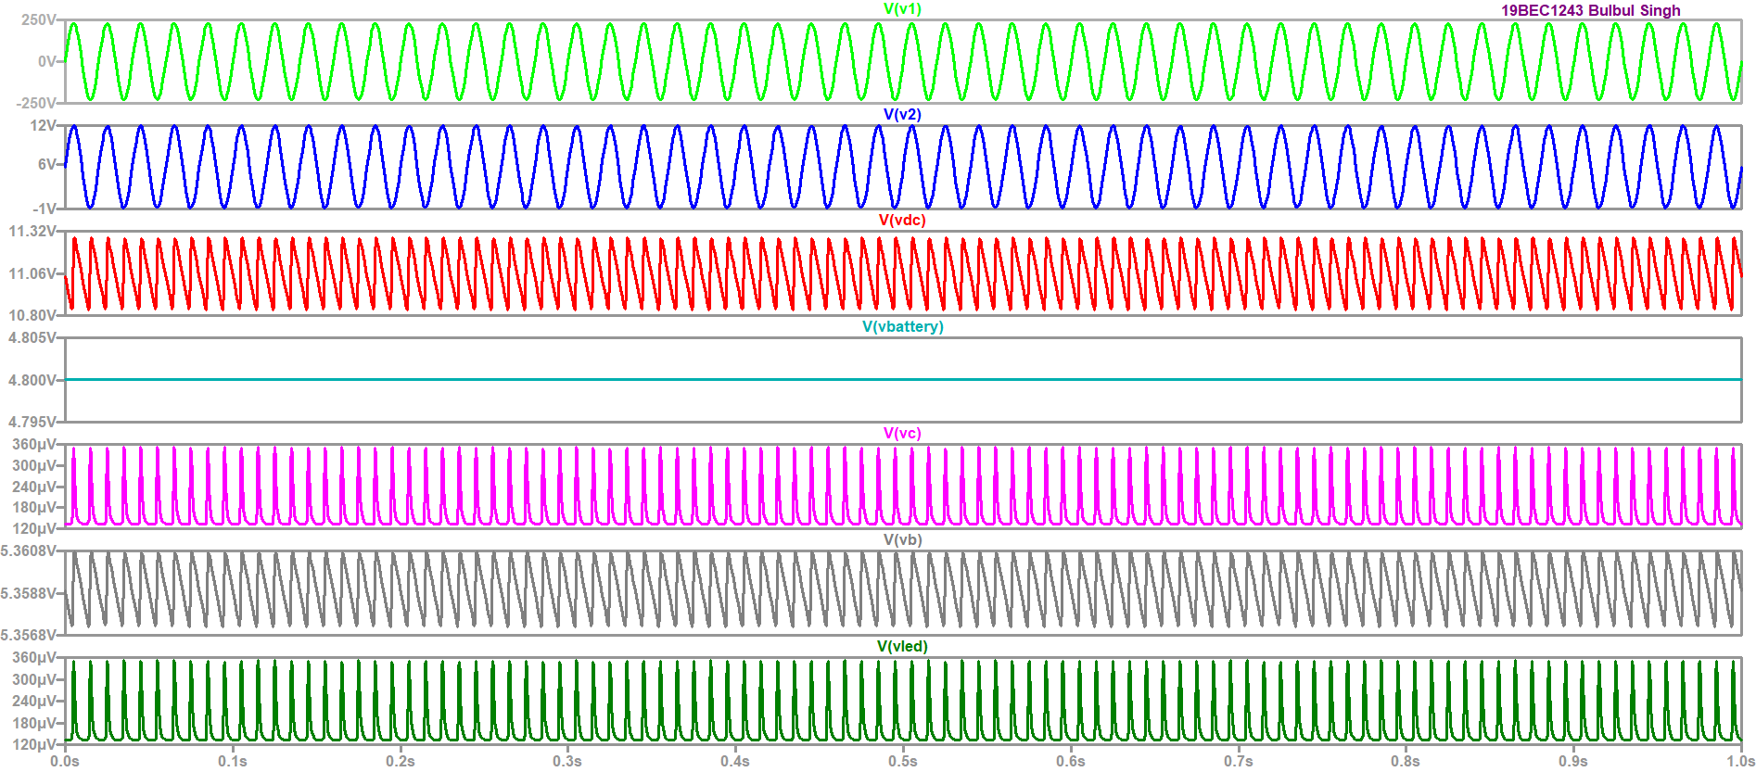

**Result:** Thus we have plotted the graph of where both S1 and S2 are on, we can observe that Vc and VLED are equal.

**Case 2: With S1 OFF, S2 ON:**

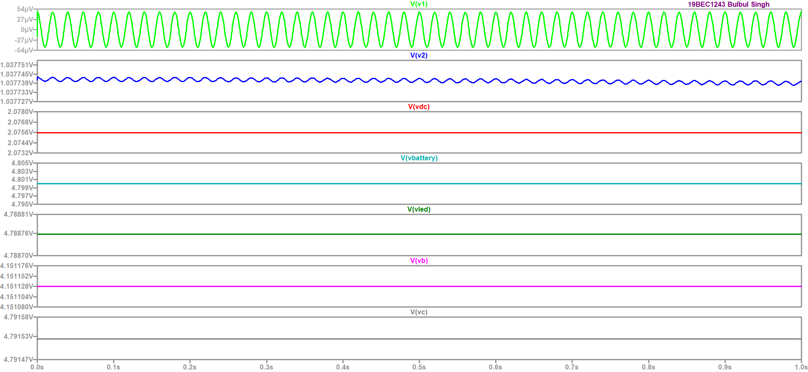

**Result:** Thus we have plotted the graph when the S1 is off and S2 is in on condition, here also we can observe that Vc and VLED are equal

**Case 3:** With S1 OFF, S2 OFF:

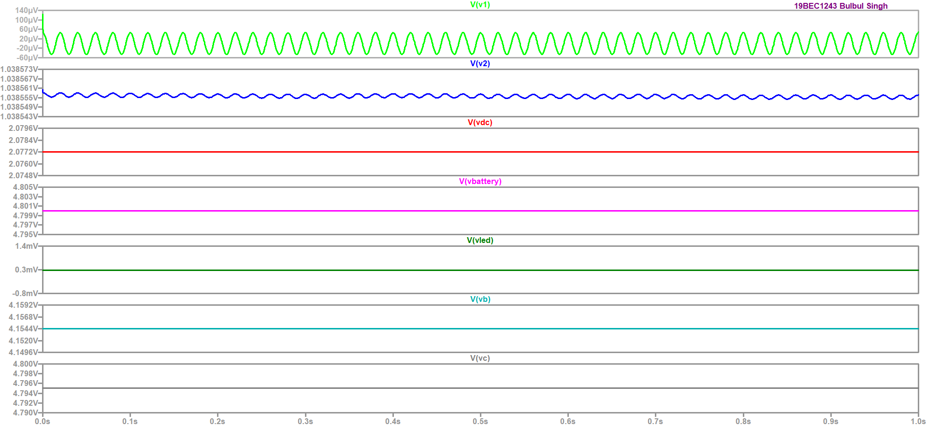

**Result:** Thus we have plotted the graph when the both switches are in off, here Vc and VLED are not equal